# System Requirements

This section outlines all the functional, non-functional and other requirements of the system.

Scale of importance:

1 - Not very important. Item/feature can be eliminated from the system

without causing harm to the system.

2 - Not necessarily important. Item/feature can be eliminated from the system

but only causing negligible harm.

3 - Important. Items/features that cannot be eliminated from the system

without causing significant harm and are somewhat critical to the proper and effective functioning of the system.

4 - Critical. Items/features that are entirely critical to the system and cannot be

eliminated for whatever reason and under any circumstance.

## Functional Requirements

### User/System Interaction Sequence Diagrams

Student/System Interaction

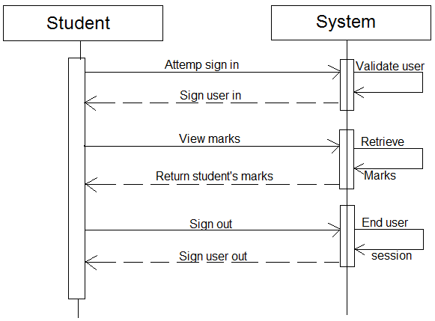

TA and Tutor/System Interaction

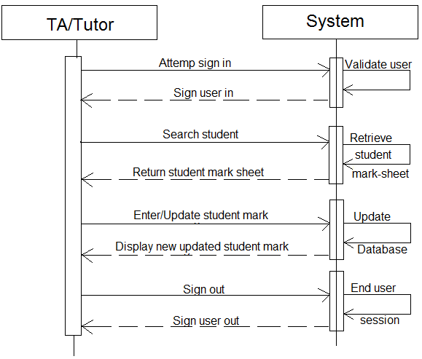

Lecturer/System Interaction

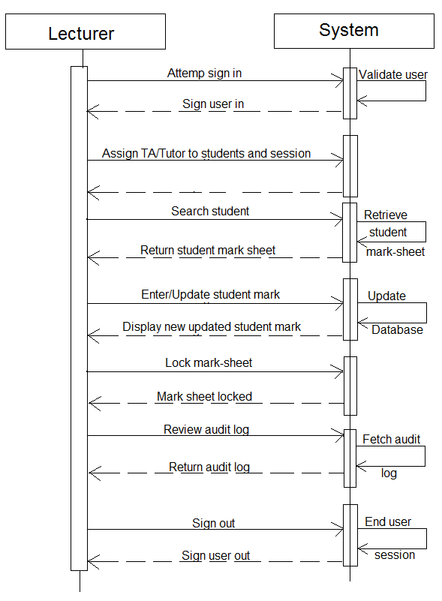

HOD/System Interaction

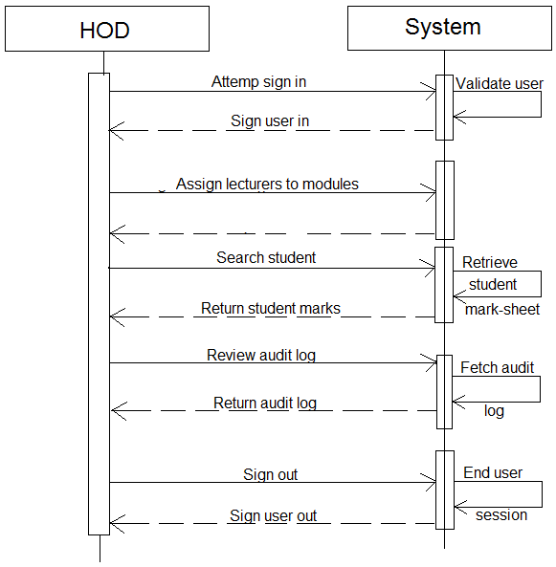

## Interface Requirements

### Graphical User Interface

All graphical user interfaces developed for this system should be simple and user-friendly to all users of the system.

### Hardware interface

The system will operate on android mobile devices along with internet-enabled computers.

## Technical Requirements

The following technical specifications are enforced and required by the client:

* A web and mobile application version of the system should be available.
* System should interface with aldap.
* System should be tested with Django.
* System should accommodate SOAP interface.
* System should operate in real-time against the database.